**INS Practical 5**

**Columnar Transposition**

**Source Code:**

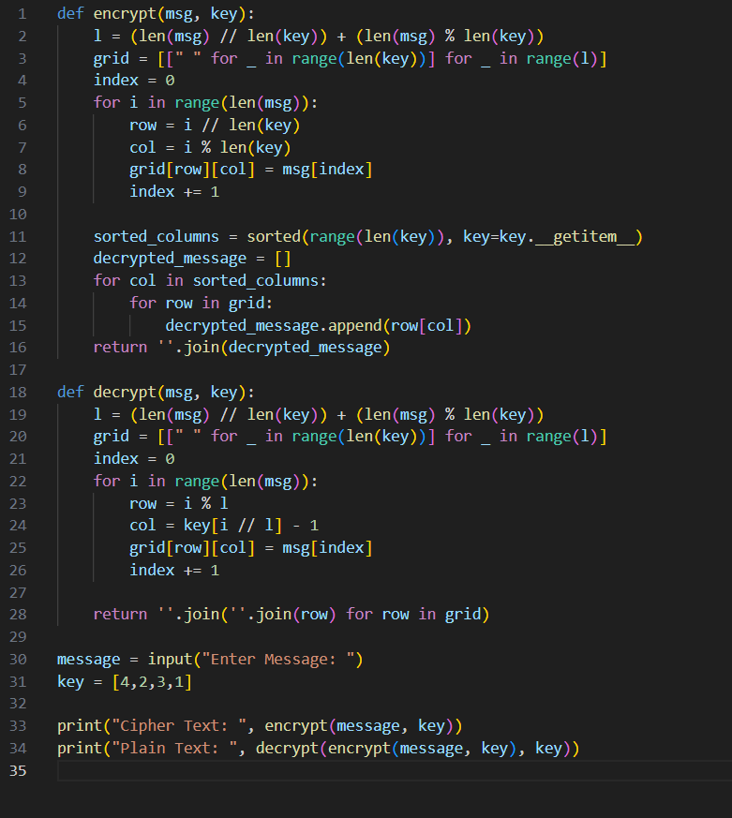

**Output:**

